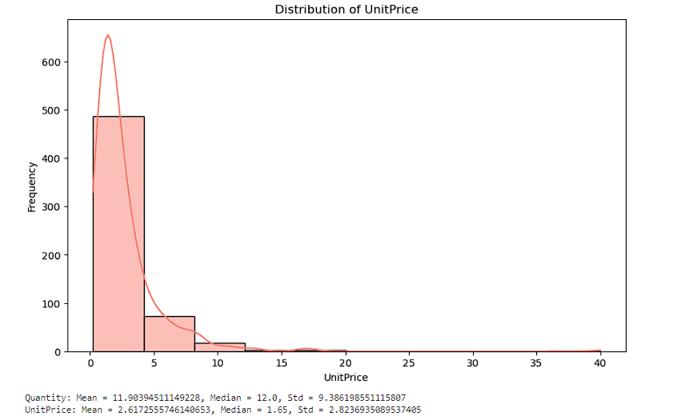

The graph and the estimated parameter suggest that there is a right skew in the distribution of unit prices. This means that there are more units sold at lower prices than at higher prices.

This type of distribution is sometimes called a Pareto distribution, or a power law distribution. Pareto distributions are often found in economics and business, where they can be used to model the distribution of income, wealth, or company sizes.

There are a number of reasons why a distribution of unit prices might follow a Pareto distribution. For example, there may be a small number of very popular products that are sold at a low price, and a large number of less popular products that are sold at a higher price. Or, there may be a few very large customers who buy units at a discount, and a large number of smaller customers who pay full price.